- INTRODUCTION
The purpose of this document is to outline the deployment information related to the implementation of Robotics Process Automation (RPA) using UiPath for the process of Voice Activation.

  - REFERENCES OF THE DOCUMENT
Sources:
https://www.uipath.com/blog/ultimate-rpa-glossary-of-terms
https://orchestrator.uipath.com/docs/robot-statuses
https://orchestrator.uipath.com/docs/about-assets

  - PROCESS DESCRIPTION
This is related to the implementation of Robotics Process Automation (RPA) using UiPath for the process of Voice Activation.

The key features of the Voice Activation, which the automated process demonstrate the following: • Automation of Voice Activation - Uploading job orders from ICCBS to orchestrator queue
• Automation of Voice Activation - Queuing tasks from obtaining job orders in the orchestrator queue

  - SCOPE
The automated process covers all activities for Voice Activation, which get all the details in ICCBS, determine the type of status if Cancel Yes or Cancel No, deleting of a new facility with the execution of the script in VIMS, and also installation of a new facility in VIMS.
This document covers the definition of terms used in Incident Management Voice Activation, used workflows, and troubleshooting. This document also describes the process to be followed for assessing an incident and determining the level of priority based on definitions of impact and urgency. Once priority is determined, the appropriate route for managing the incident resolution process is followed.

- REQUIREMENTS
Voice Activation process requires the following system:

Check this link for credentials: https://docs.google.com/spreadsheets/d/1EO2j45W70KHqrcjwDRzMdcjFO6qpERaiUAXkA7EMDh0/edit#gid=1571090556

- Virtualized IP. Multimedia Services (VIMS)
- Integrated Customer Care and Billing System (ICCBS)

  - TECHNICAL REQUIREMENTS AND ASSUMPTIONS / IT
Preconditions on Running the Robot/s

Before the bot can automatically run, we have to ensure the following:

• Package is uploaded in the orchestrator.
• Robot is connected and available.
• Schedule set in orchestrator is correct.
• VIMS is open and logged-in.
• Assets (Credentials, URLs) are updated in the orchestrator.

  - REQUIREMENTS AND BUSINESS ASSUMPTIONS
- Remarks for Fallout report
- All the requirement are based on the process map and acceptance criteria

Check this link: https://drive.google.com/drive/u/0/folders/1R6_5-k2oozK4aM74Qa52WtSV17vtlTOZ

- DIAGRAMS AND DESCRIPTION
  - PROCESS / BOT
The package will be deployed to the Orchestrator. The Orchestrator will then run the robot based on the schedule that is set to 12:00 AM to 11:59 PM. All the tickets that the ROBOT will read will come from the Queue of Orchestrator which all the data are from the Business Unit. After the transaction has been taken, the ROBOT will navigate to the ICCBS web tool to process the job orders, then generate a script for deletion and activation of the facility. After successful processing, the ROBOT will then return to the Google sheet to send an email for the successfully processed job order. All the fallouts will be written on a separate tab on the Google Sheet for monitoring.
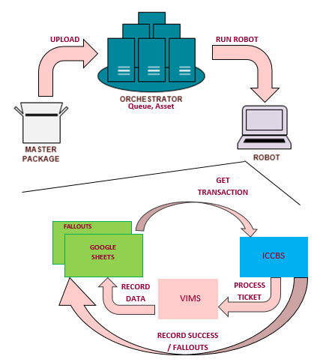

Check this link for the Process Map of Voice Activation: https://drive.google.com/drive/u/0/folders/1R6_5-k2oozK4aM74Qa52WtSV17vtlTOZ

  - ACTIVITIES
- ICCBS – bot took all the job details like Status of Job Order Number, Cabinet Number, Account Number, Service Number, Job Type etc. http://iccbs.globetel.com.ph:8010/dataworksorder-webapp/DataWorksOrder/login
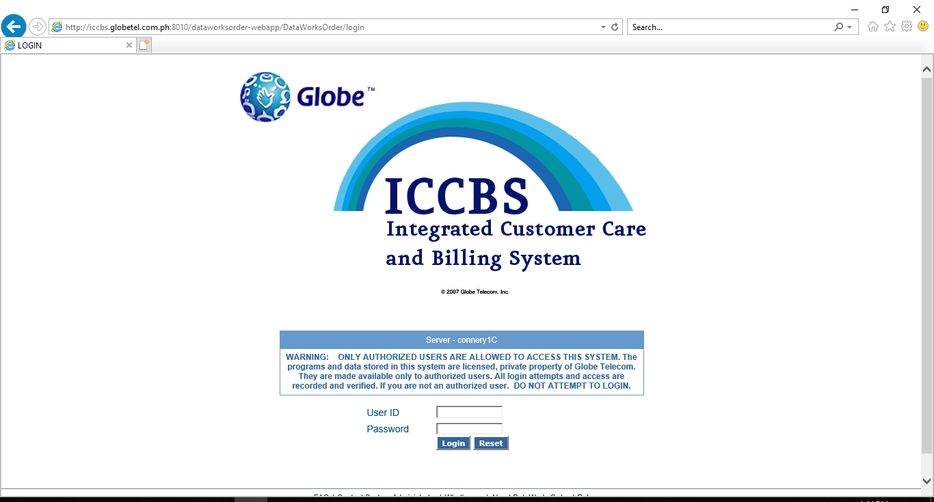

- Voice Activation process used VIMS for deleting and installing new facility.
https://globebroadbandcfs.zendesk.com/
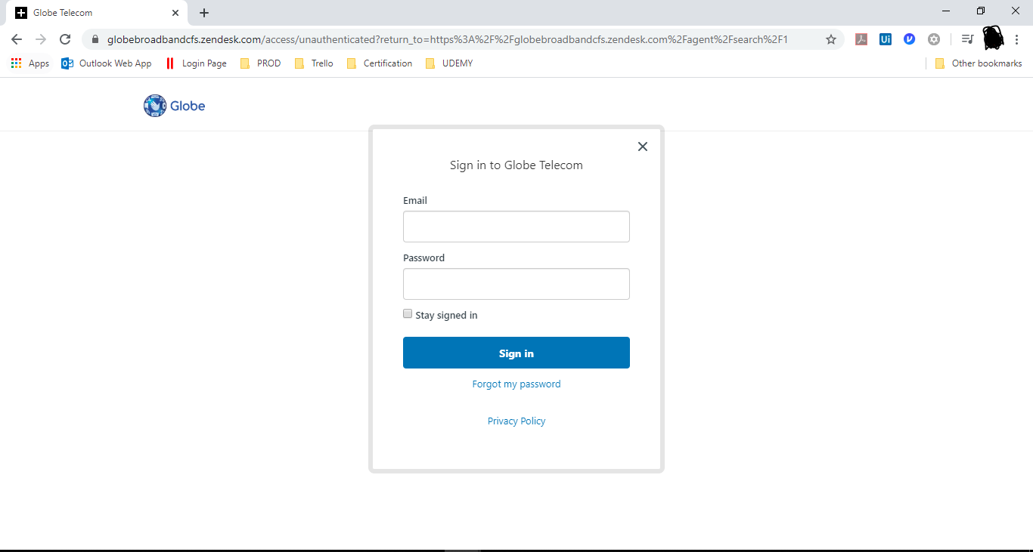

- GENERATION AND TREATMENT OF ALERTS AND EXCEPTIONS
Alerts will impact the process and business drivers. In this section if they number all the alerts and their method of communication. The definition of how to act in the face of all the alerts described should be in the ODH.

The process-lifting team must take the details and document the necessary procedures to react on those alerts in the PDD.

EVENT  (Alert or Exception) | SYSTEM OR BUSINESS | ROBOT ACTION AND DETAILS
System Error | System, which occurs in Init state then it will go End Process state. | All working application will be closed.
Business Rule Exception | Business, which an error rooted in the fact that certain data which the automation project depends on is incomplete or missing. | Bot consolidate the details in Google Sheet with Error Reason. Then, proceed to another transaction.

- DATA AND CREDENTIALS SECURITY
  - DATA STORAGE
This section is to detail all data storage locations (e.g. email, network folders, etc.) that touch the operation or belong to the operation.
The operation may be necessary to develop "managements" in these data storage locations according to the records management policies.

    - DATABASE
All transaction logs and jobs processed are all stored in the data base where the orchestrator is connected. UiPath highly suggested the Microsoft SQL data base especially for windows base environment.

EMAIL
- Check the emails for automated Voice Activation in this link: https://docs.google.com/spreadsheets/d/1EO2j45W70KHqrcjwDRzMdcjFO6qpERaiUAXkA7EMDh0/edit#gid=1571090556
    - NETWORK UNITS / FOLDERS
- N/A
    - OTHERS
- Google Spread Sheet- Fallout and Success Consolidation of process
https://docs.google.com/spreadsheets/d/1d91G7ItIEISuWi3fRju1CtUXIZywblKMu2gCMHmarJ4/edit#gid=1520128823
  - DATA PRIVACYs
- Orchestrator – Assets, Package and Queues
- All logs and assets that are stored in the orchestrator are secured with the admin access that manages it. Also all the credentials and other data that needs to secure are encrypted in the orchestrator.

  - CREDENTIALS
- Check this link for credentials: https://docs.google.com/spreadsheets/d/1EO2j45W70KHqrcjwDRzMdcjFO6qpERaiUAXkA7EMDh0/edit#gid=1571090556
- As already stated in privacy, all credentials that are stored in the orchestrator are encrypted.

- ASSISTED AUTOMATION PROTOCOL
METHOD | LOCATION | FORMAT | PROGRAMMING
VIMS | https://10.166.18.146:8543/spg/login.jsp | - Manually Login | N/A

- MANAGEMENT INFORMATION REPORTS (MI)
Communication Method
- Microsoft Excel
- Google Spreadsheet

Format
For the assets of the process, check this link: https://docs.google.com/spreadsheets/d/1EO2j45W70KHqrcjwDRzMdcjFO6qpERaiUAXkA7EMDh0/edit#gid=1571090556

Programming
- UiPath uses Visual Basic programming language.

- AUTOMATED MASTER PROJECT DETAILS
Details filled in by the developer reflect the actual information for the master project released for production.
 | PROJECT DETAILS | DESCRIPTION
1 | Master Project Name and Version | Performer_-_Voice_Activation.[PackageVersion]
2 | Robot Type (Specify if the process was automated for FOR or BOR or mix) | Voice Activation - BOR
3 | Is Orchestrator used? (Yes/No) | Yes
4 | Scalable? (Yes/No)(Can the process be run by multiple robots in parallel) | Yes

- PROJECT DETAILS
PROJECT NAME: VOICE ACTIVATION
    - WORKFLOW(S) SPECIFIC TO Excel
 | .xaml File | Description | Input | Output
1 | Excel_ActivateFacility_Globe | Workflow that activate the new facility in VIMS | in_SipType  in_Config  in_ServiceID in_CabinetNumber  in_Pots  in_AccountNumber | out_Status
2 | Excel_DeleteNewFacility | Workflow that delete the new facility in VIMS | in_Config  in_ServiceNumber | out_Status

    - WORKFLOW(S) SPECIFIC TO Google Spread Sheet
 | .xaml File | Description | Input | Output
1 | GoogleSheet_GenerateErrorReport | Workflow that consolidate an error report with specific error reason. | in_ErrorReason  in_dr_TxnItem  in_Config  in_TaskName
2 | GoogleSheet_GenerateErrorReportForException | Workflow used to consolidate an error if bot encounter system error.  Error Reason: "Encountered unhandled exception. ICCBS / VIMS is logged out." | in_Config  dr_JobDetails
3 | GoogleSheet_GenerateErrorReportVimsLogout | Workflow used to consolidate an error if VIMS is logout. | in_ErrorReason  in_dr_TxnItem  in_Config  in_TaskName
4 | GoogleSheet_GenerateSuccessReport | Workflow that consolidate success report. | in_dr_TxnItem  in_Config  in_TaskName

    - WORKFLOW(S) SPECIFIC TO ICCBS
 | .xaml File | Description | Input | Output | IN/OUT
1 | ICCBS_CheckStatusIfSetToCAN | A workflow that does the checking if successfully changed the Status to CAN |  | out_CANIsSuccessful
2 | ICCBS_CheckStatusIfSetToCOM | A workflow that does the checking if successfully changed the Status to COM |  | out_COMIsSuccessful
3 | ICCBS_Close | A workflow used to close the ICCBS
4 | ICCBS_CloseAll | A workflow used to close all the windows of ICCBS
5 | ICCBS_GetJobDetails | This workflow extracts Job Details from ICCBS and Orchestrator. | in_TransactionItem  in_Config | out_JobActivityStatus  out_SwitchFacility  out_JobOrderStatus  out_JobType  out_CancelStatus  out_dtJobDetails  out_CallSource  out_CabinetNumberOld  out_SipType  out_Cabinet | dr_TxItem
6 | ICCBS_GetJobDetailsInICCBS | This workflows gets all the details in ICCBS. | QueueID |  | NodeID  SignallingIP  TIDNumber  Switch  out_CallSource  CallSource  AccountNumber  Area  JobType  ServiceID  CabinetNumberOld  CabinetNumber  in_Config dr_TxItem
7 | ICCBS_GetJobDetailsinQueueItem | Workflow that gets all the details in Queue Item. | in_TransactionItem |  | CancelStatus  JobOrderStatus  QueueID  JobOrderNumber
8 | ICCBS_GetJobDetailsStringManipulation | A workflow for manipulation of CabinetID, Area, Telephone Num, and SIP type | CabinetNumber  Area  ServiceID in_Config |  | SIPType  Zone  AreaCode  TelephoneNumber
9 | ICCBS_Login | A workflow for login of ICCBS | in_ICCBSCredential  in_ICCBSUrl |  | in_Config  dr_TxtItem
10 | ICCBS_NavigateToJobDetails | A workflow that navigates to job details of ICCBS | in_JobNumber | out_JobNumber
11 | ICCBS_SetStatusToCAN | A workflow that does the changing of Status to CAN
12 | ICCBS_SetStatusToCOM | A workflow that does the setting of Status to COM
13 | ICCBS_WaitElement | Workflows which waits the banner for job activity list. | in_Config  in_drJobDetails
    - WORKFLOW(S) SPECIFIC TO VIMS
 | .xaml File | Description | Input | Output
1 | VIMS_ExecuteScript_Delete | Workflows that execute the deletion script in VIMS | in_Config | out_TaskName  out_Status
2 | VIMS_ExecuteScript_Install | Workflows that execute the installation/activation script in VIMS | in_Config | out_TaskName  out_Status

- OTHER DETAILS
  - FUTURE IMPROVEMENTS
- Enhancement depends on the Project Owner.
  - DEBUGGING TIPS
- If bot stop running, there are two reason as to why it happened:
- Robot/s stopped running the job; or
- Robot/s became Unresponsive or Disconnected
- Check logs in orchestrator
  - OTHER REMARKS

- POST UAT SPECIFICATIONS
Average duration per transaction: (varies depending on the Test environment)
Recommended number of robots for the specified volumes:
Specified schedule:

- DEFINITIONS
  - DEFINITION OF TERMS
TERMINOLOGY | DEFINITION
UiPath | The automation tool used in developing robot/s.
UiPath Robot | A software robot that is developed to execute the tasks on an interface level and mimic human actions within the systems.
UiPath Orchestrator | Allows a company to schedule, manage, and monitor all robots in one secure place.
Package | The developed robot scripting that is deployed in the orchestrator.
Asset | Represents shared variables or credentials that can be used in different automation projects.

  - ACRONYMS
ACRONYM | DEFINITION
RPA | Robotics Process Automation
URL | Uniform Resource Locator
VA | Voice Activation
VIMS | Virtualized IP. Multimedia Services

